**PIR Sensor**

**Introduction**

PIR sensors allow you to sense motion. They are used to detect whether a human has moved in or out of the sensor’s range. They are commonly found in appliances and gadgets used at home or for businesses. They are often referred to as PIR, "Passive Infrared", "Pyroelectric", or "IR motion" sensors.

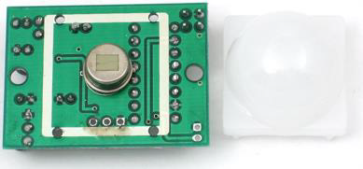

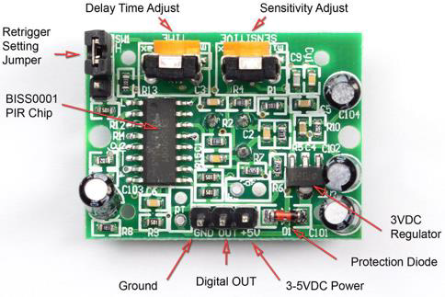

**Working of PIR Sensor**

PIRs are made of pyroelectric sensors, a round metal can with a rectangular crystal in the centre, which can detect levels of infrared radiation. Everything emits low-level radiation, and the hotter something is, the more radiation is emitted. The sensor in a motion detector is split in two halves. This is to detect motion (change) and not average IR levels. The two halves are connected so that they cancel out each other. If one-half sees more or less IR radiation than the other, the output will swing high or low. PIRs have adjustable settings and have a header installed in the 3-pin ground/out/power pads.

When the sensor is idle, i.e. there is no movement around the sensor; both slots detect the same amount of infrared radiation, resulting in a zero output signal.

But when a warm body like a human or animal passes by; it first intercepts one half of the PIR sensor, which causes a positive differential change between the two halves. When the warm body leaves the sensing area, the reverse happens, whereby the sensor generates a negative differential change. The corresponding pulse of signals results in the sensor setting its output pin high.

**Hardware Overview of PIR Sensor**

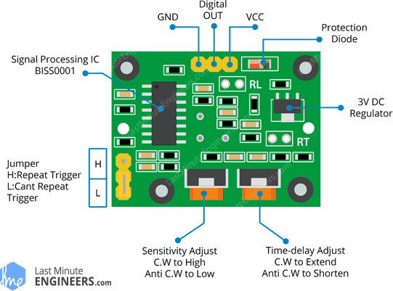

There are two potentiometers on the board to adjust a couple of parameters:

**Sensitivity–** This sets the maximum distance that motion can be detected. It ranges from 3 meters to approximately 7 meters. The topology of your room can affect the actual range you achieve.

**Time–** This sets how long that the output will remain HIGH after detection. At minimum it is 3 seconds, at maximum it is 300 seconds or 5 minutes.

The board has a jumper (on some models the jumper is not soldered in). It has two settings:

**H–** This is the Hold/Repeat/Retriggering In this position the HC-SR501 will continue to output a HIGH signal as long as it continues to detect movement.

PIR Sensor Retriggering Repeat Mode Jumper Setting

**L–** This is the Intermittent or No-Repeat/Non-Retriggering In this position the output will stay HIGH for the period set by the TIME potentiometer adjustment.

PIR Sensor Non-Retriggering No-Repeat Mode Jumper Setting

**Pinout of PIR Sensor**

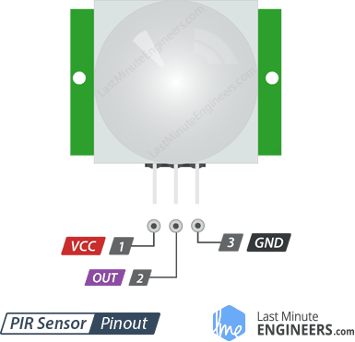

VCC is the power supply for HC-SR501 PIR sensor which we connect the 5V pin on the Arduino.

Output pin is a 3.3V TTL logic output. LOW indicates no motion is detected; HIGH means some motion has been detected.

GND should be connected to the ground of Arduino.

**Expected Output**

